**EXPERIMENT:2** Create a simple cloud software application for Property Buying & Rental process (In Chennai city) using any Cloud Service Provider to demonstrate SaaS include the necessary fields such as Buy, Rent, commercial, Rental Agreement , Rental Agreement, Area, place, Range, property value etc.

**AIM:** To Create a simple cloud software application for Property Buying & Rental process (In Chennai city) using any Cloud Service Provider to demonstrate SaaS

**PROCEDURE**:

**step1**: Go to zoho.com.

**step 2**: Log into the zoho.com.

**step 3**: Select one application step.

**step4:** Enter application name as property buying & rental.

**step 5:** Created new application as property buying & rental.

**step 6**: Select one form

**step 7**: The software has been created.

**IMPLEMENTATION: Login**

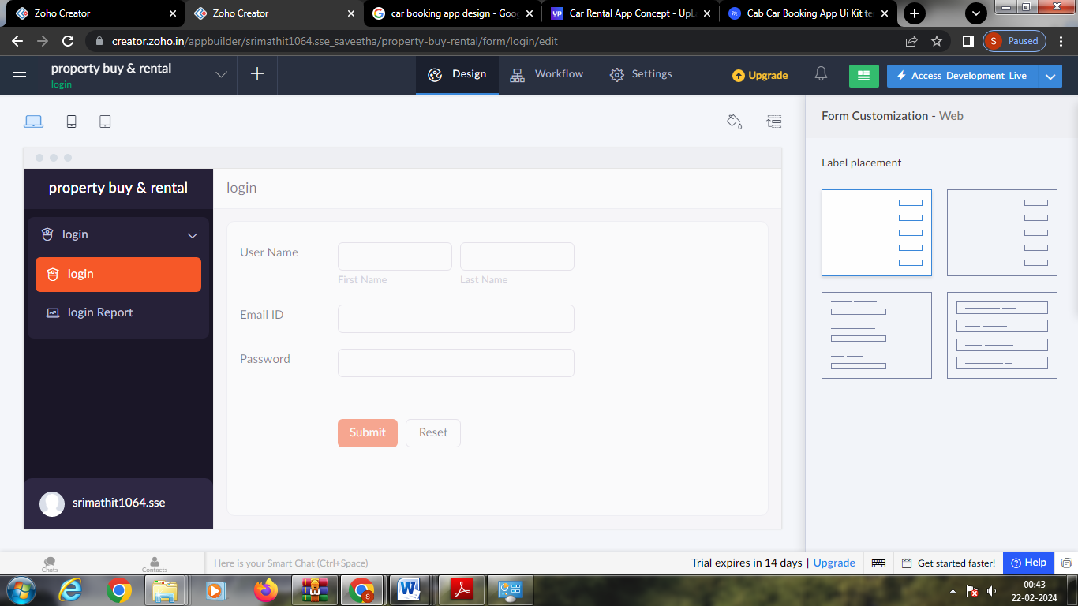

**Rental details**

